Biotechnology Book Project

Cover – Title, Color Picture, Your Name

Pages 2 (Inside Cover) & 3 – Answer the following questions: What is biotechnology?
What is the Human Genome Project? What are the ethical concerns about the HGP?
What are 5 examples of biotechnology?

Pages 4 & 5 – Transgenic Organisms – A description of how the process is done. Answers to the following questions:
What is a restriction enzyme? What is a plasmid? What is recombinant DNA?
Why is bacteria used? What are 2 medicines made by using transgenic organisms?
What does GMO stand for? Draw a picture showing the process

Pages 6 & 7 – Gel Electrophoresis Answer the following questions:
Why does everyone’s DNA cut into different size pieces?
Why do the DNA fragments move toward the positive end of the gel?
Which fragments move farther through the gel? What are 2 uses for gel electrophoresis?
Draw a picture showing the process Give a description of what happens during the process

Pages 8 & 9 – Gene Therapy Answer the following questions? What is Cystic Fibrosis?
How is gene therapy used to treat genetic disease? What is SCID?
Draw a picture showing the process Give a description of what happens during the process

Pages 10 & 11 – Cloning Draw a picture showing the process
Give a description of what happens during the process

Page 12 (Back Cover) – Dedication page OR About the Author page – YOUR CHOICE!!
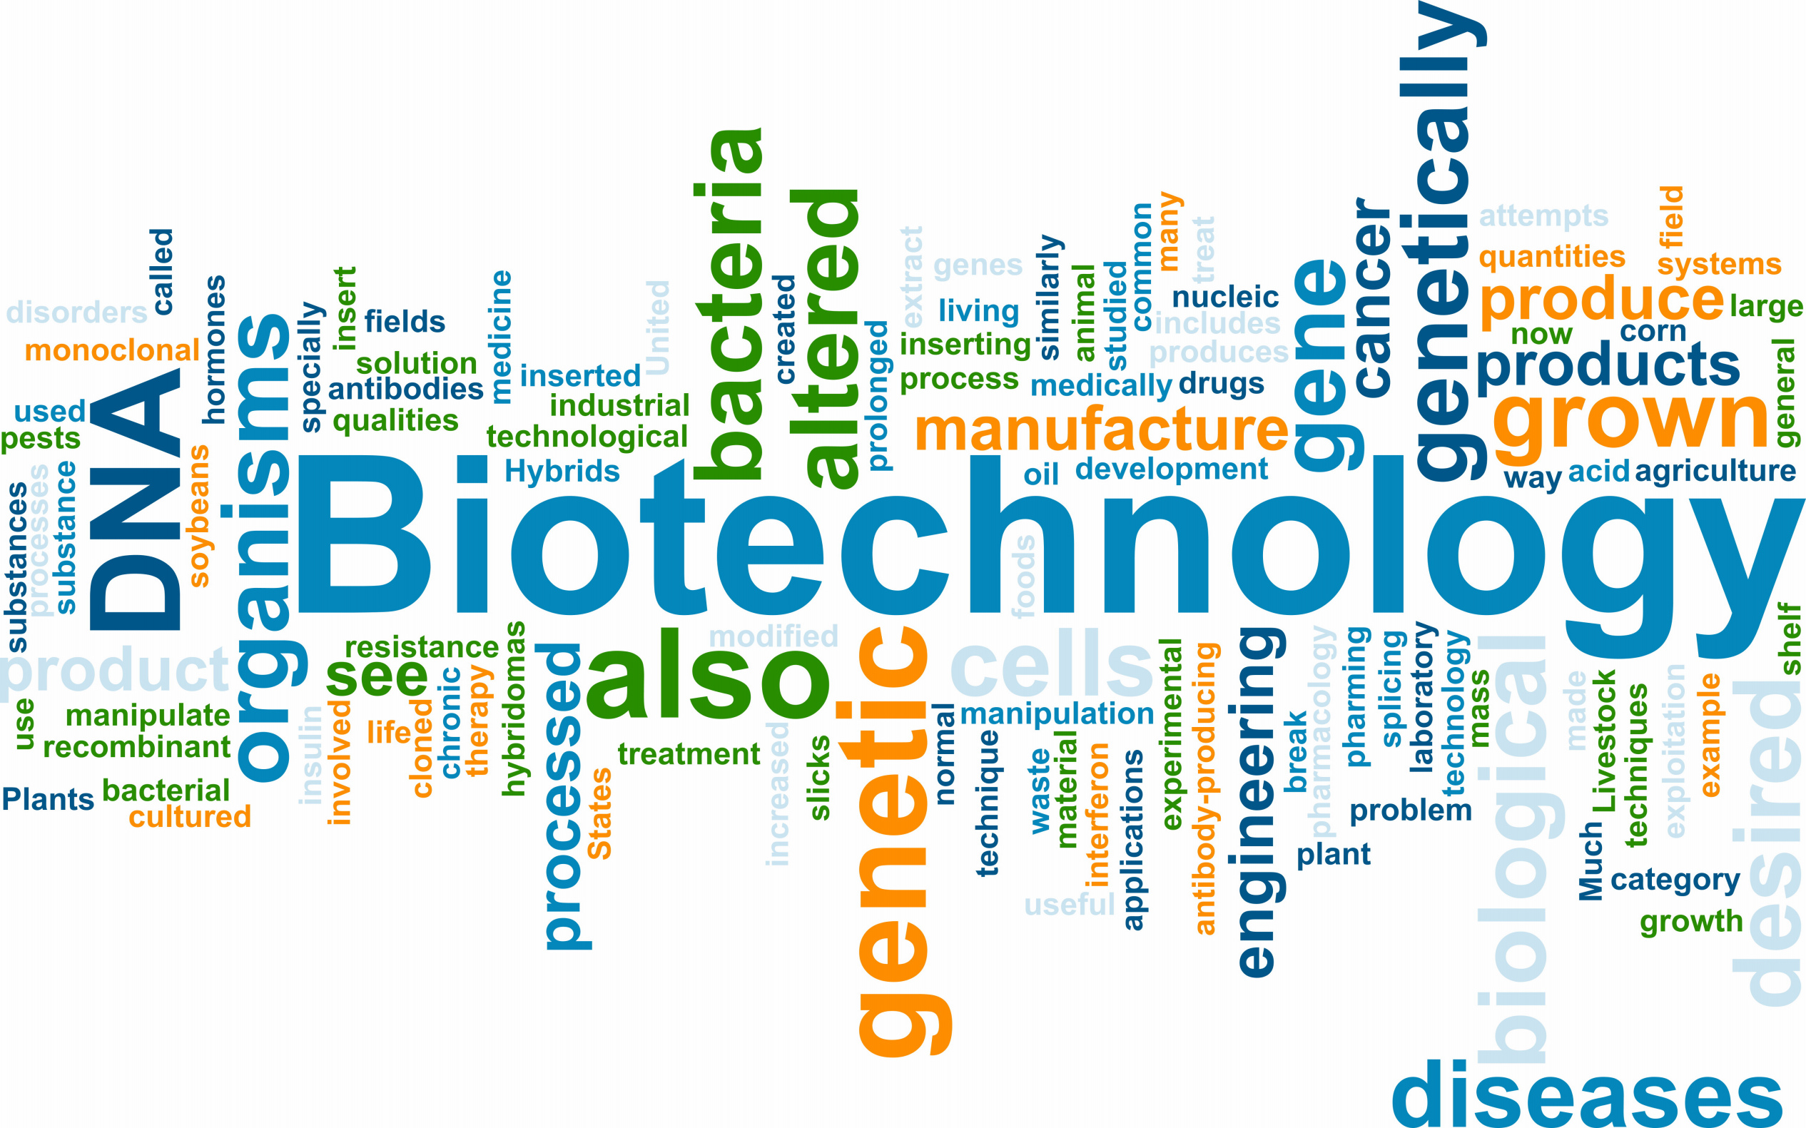
DUE DATE – This is worth a
A Day Classes 100 point
Monday, Feb 1st FORMAL Test
Grade!!
B Day Classes
Tuesday, Feb 2nd
Biotechnology Book Project

Cover – Title, Color Picture, Your Name

Pages 2 (Inside Cover) & 3 – Answer the following questions: What is biotechnology?
What is the Human Genome Project? What are the ethical concerns about the HGP?
What are 5 examples of biotechnology?

Pages 4 & 5 – Transgenic Organisms – A description of how the process is done. Answers to the following questions:
What is a restriction enzyme? What is a plasmid? What is recombinant DNA?
Why is bacteria used? What are 2 medicines made by using transgenic organisms?
What does GMO stand for? Draw a picture showing the process

Pages 6 & 7 – Gel Electrophoresis Answer the following questions:
Why does everyone’s DNA cut into different size pieces?
Why do the DNA fragments move toward the positive end of the gel?
Which fragments move farther through the gel? What are 2 uses for gel electrophoresis?
Draw a picture showing the process Give a description of what happens during the process

Pages 8 & 9 – Gene Therapy Answer the following questions? What is Cystic Fibrosis?
How is gene therapy used to treat genetic disease? What is SCID?
Draw a picture showing the process Give a description of what happens during the process

Pages 10 & 11 – Cloning Draw a picture showing the process
Give a description of what happens during the process

Page 12 (Back Cover) – Dedication page OR About the Author page – YOUR CHOICE!!

DUE DATE – This is worth a
A Day Classes 100 point
Monday, Feb 1st FORMAL Test
Grade!!
B Day Classes
Tuesday, Feb 2nd

