EOC Quick Study guide
Sterngrr
Homeostasis –

chemistry
organic -
4 types -

Carbohydrates –
Use -
Building blocks -
Indicator tests –
Simple sugars -

Starches -

Cellulose -

structure

lipids –
use -
building blocks -
indicator test -

structure

protein
use -
building blocks -
indicator test -

structure

nucleic acids
Nucleic acids
use -
building blocks
structure

ph scale

enzymes –

structure

Cells
Prokaryotic -
Examples -
Eukaryotic -
Examples -

Organelles
Organelle | Function | Found in plant, animal or BOTH cells?
Nucleus

Ribosomes

Mitochondria

Chloroplast

Cell Membrane

Cell Wall

Transport
Cell membrane -
Passive transport -
Diffusion -
Osmosis -
Active transport -

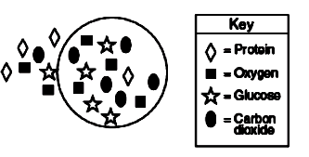
Practice questions
According to the diagram to the left, which statement best describes the general direction of diffusion across the membrane of this cell? This cell membrane is permeable to all materials.
A) Glucose would diffuse into the cell.
B) Protein would diffuse out of the cell.
C) Carbon dioxide would diffuse out of the cell.
D) Oxygen would diffuse into the cell.

According to the diagram above, which direction would glucose move? This cell membrane is permeable to everything.
A) Glucose would diffuse into the cell via diffusion. B) Glucose would diffuse out of the cell via diffusion
C) Glucose would dissolve. D) Glucose would combine with carbon dioxide

Why is diffusion a type of passive transport? A) It moves materials across a cell membrane B) It does not require any of the cell’s energy. C) It does not need activation by an enzyme. D) It continues until equilibrium is reached.

You are conducting osmosis experiments with a test tube of human cells in solution. You add a teaspoon of table salt to the test tube. According to the principles of osmosis, what can you predict will happen to the cells? A) They will swell and burst. B) They will not be affected. C) They will shrink and shrivel. D) They will undergo rapid mitosis.

Photosynthesis & Cell respiration
general reactions

photosynthesis

Cell respiration

Aerobic & anaerobic respiration
Aerobic respiration -

Anaerobic respiration -

Two types –

Photosynthesis & Cell respiration experiments

Mitosis
Interphase -
G1 -
S -
G2 -
Prophase -

Metaphase -
Anaphase -
Telophase -
Cytokinesis -
How to remember the order -
Plant vs. animal cytokinesis -

Chromosomes
Replicated (doubled) during this phase -
Travel in pairs known as
Attach to spindle fibers at the

interphase prophase

Metaphase anaphase

Telophase cytokinesis

Mitosis vs. meiosis
There are 2 types of cells _______ cells and ______ cells (also called ________________)
Human body cells have _______ chromosomes ( ______________ )
Human body cells are called __________________ (____ of every chromosome)
1 from ______ & 1 from ______
Human sex cells have _______ chromosomes (______& __________ cells)
Human sex cells are called __________________ (_____ of every chromosome)
______________________________ 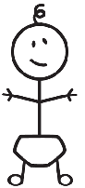
23
23
46
_________________ makes ________ cells
You start with____ cell and end with _____

The offspring are ____________________
__________________to the parent
_________________ makes _________ cells
You start with ____ cell and end with _____
46
Skin cell
46 Testicle Cell
46
Skin cell
46
Skin cell
23
23
23
23
The offspring are ___________________
_________________ to the parent

Asexual vs. sexual reproduction
Asexual -
Advantage -
Disadvantage -
Sexual -
Advantage -
Disadvantage -

Inheritance & punnett squares
Trait -
Allele -
Dominant -
Recessive -
Homozygous/pure -
Heterozygous/hybrid -
Phenotype -
Genotype -
Punnett square -

Non-mendelian inheritance
Incomplete -

Codominance -

Multiple alleles -

Sex-linked -

Dna,rna & protein synthesis
DNA Structure RNA Structure

Dna rna protein

Happens in happens in
Product product

Mrna -

Rrna -

Trna -

Translation diagram

DNA strand – atc gga cat acg
Mrna strand -
Amino acids -

Biotechnology
Transgenic organism -
~made with
5 steps

~used to make

Gene therapy -
~used to treat diseases
Such as

Human genome project-
~used to identify locations of all disease causing genes
~better treatment
~gene therapy

Gel electrophoresis
~also called

~used for

Karyotypes

Evolution
Charles Darwin -
o-
v-
c-
s-
all evolution is driven by
If that mutation causes you to be better fit to your environment, you will survive and pass that mutation to your offspring
Speciation -

Evidence for evolution
1. fossils -
2. homologous structures -

Shows

3. vestigial structures -
~ex.

4. biochemical evidence –

antibiotic resistance in bacteria

Classification
Binomial nomenclature -
7 taxons from
Dichotomous keys

Bird w-
Bird x -
Bird y -
Bird z -
Largest to
Smallest

Cladograms -

Six kingdoms of life

Six kingdoms of life
Viruses -

Archaebacteria -

Eubacteria -

Protists -

Fungi -

Plants -
Vascular vs. non-vascular gymnosperm vs. angiosperm

Plant tropisms -
Plant regulating hormones –
Auxins –
Cytokinens –
Ethylene -

Animals -
Invertebrate -
Vertebrate -
Symmetry –
Radial bilateral asymmetry

Animal behavior
Instinct/Innate behavior -
~flight or fight -

~reflex -

~courtship -

~territoriality –

~aggression -

~dominance hierarchy -

~taxis -

Behavior cycles
~circadian rhythm -
~hibernation -
~estivation -
~migration -

Learned behaviors -
~habituation -

~classical conditioning -

-ex. Pavlov’s dogs
~operant conditioning -

~imprinting -

~communicating -

~social behavior -
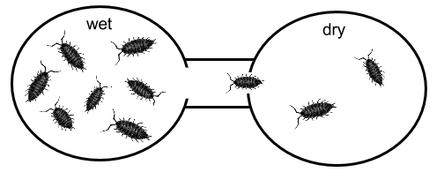

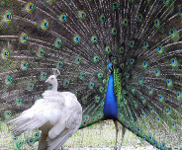
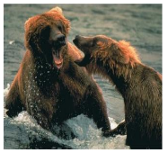

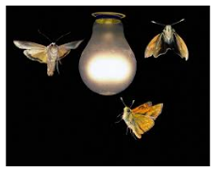
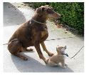
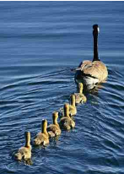
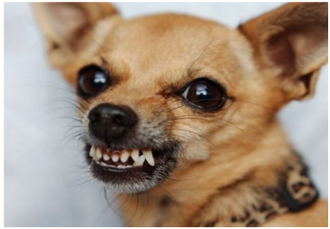
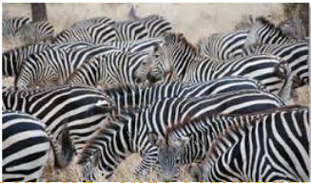

Ecology
General vocabulary
~biosphere-
~population-
~community-
~biotic factor -
~examples -
~abiotic factor -
~examples -

~producer -

~also called
~consumer -

~also called
Herbivore -
Carnivore -
Omnivore -
Decomposer - ` ~main decomposers -
Food chain/web -
Only of energy travels from link to link, the rest is lost as !!

Symbiotic relationships
Mutualism | Commensalism
Parasitism | Predator/prey
Population growth
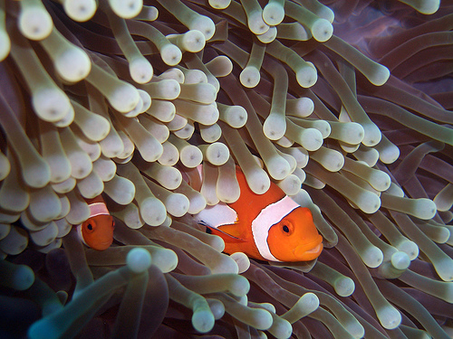
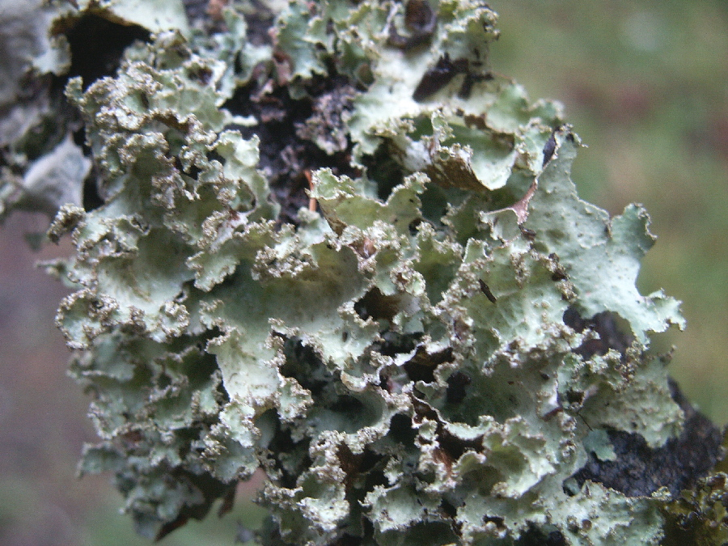
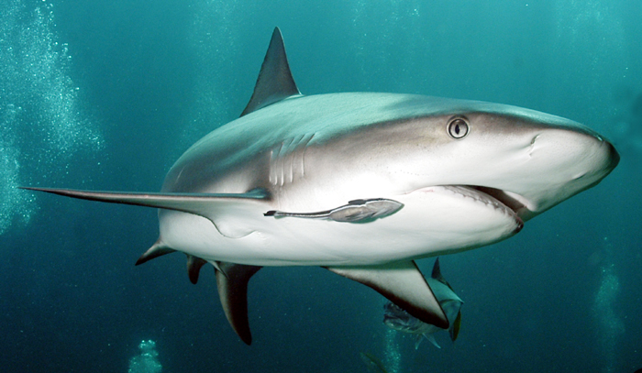
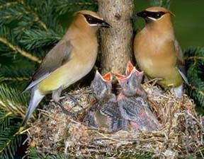
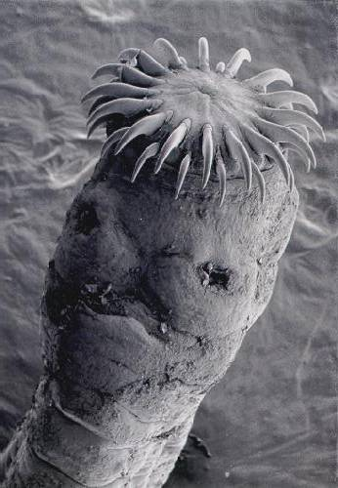
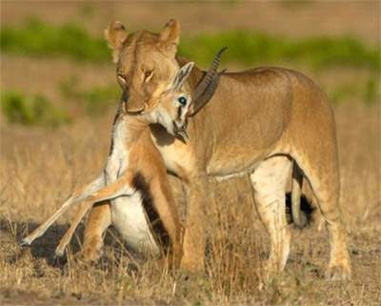
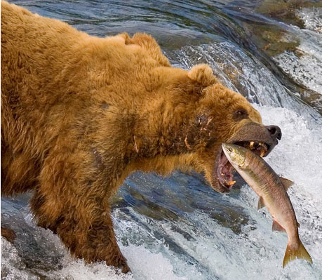
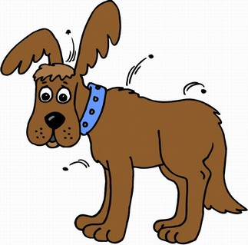
Exponential growth -

Logistic growth -

Predator/prey curves -

Limiting factors
Density-dependent -
~examples -
Density-independent -
~examples -
Nutrient cycles
Water cycle -
Carbon cycle -

Nitrogen cycle -


