Organic Chemistry Foldable Directions

1. On the top of each flap, write the name of one of the 4 types of organic compounds.
2. Under each flap in your foldable, write the following information about that type of organic compound:
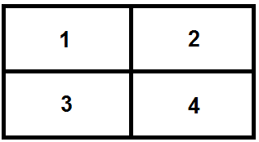
a. What does the body uses this compound for?
b. What elements make up this compound?
c. What are its subunits? What is it made of?
d. Where do we find this compound?
e. How do we test for this compound? (YOU WILL DO THIS TOMORROW)
f. Draw 2 pictures – 1 of the molecule itself, and 1of a source of the molecule. (ex. Carbohydrates – bread, potato, pasta, etc.)
3. Complete the chart and glue it to the back of your foldable

Organic Chemistry Foldable Directions

1. On the top of each flap, write the name of one of the 4 types of organic compounds.
2. Under each flap in your foldable, write the following information about that type of organic compound:
a. What does the body uses this compound for?
b. What elements make up this compound?
c. What are its subunits? What is it made of?
d. Where do we find this compound?
e. How do we test for this compound? (YOU WILL DO THIS TOMORROW)
f. Draw 2 pictures – 1 of the molecule itself, and 1of a source of the molecule. (ex. Carbohydrates – bread, potato, pasta, etc.)
3. Complete the chart and glue it to the back of your foldable

Organic Molecule | What elements make it up? | What are the building blocks? | What is the function? | How do we test for its presence? | Draw the structure
Lipid |  |  | Stored Energy
Carbohydrate |  | Simple Sugars  ex. Glucose
Nucleic Acid |  |  |  | No Test Available
Protein | CHON

