Organic Chemistry
Organic – a molecule that contains CARBON, HYDROGEN, and OXYGEN

Water H₂O inorganic missing C
Carbon Dioxide CO₂ inorganic missing H
Table Salt NaCl inorganic missing all 3
Glucose C₆H₁₂O₆ organic

There are 4 types of organic compounds used by the body
Carbohydrates Lipids Proteins Nucleic Acids

Carbohydrates
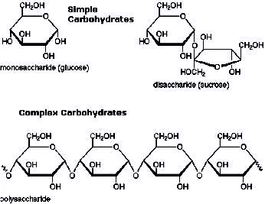
Contains CHO
Used for QUICK energy
Made of simple sugars – glucose
Found in sweets, fruits & vegetables, and starches (pasta, bread, potatoes)
Recognized by their ring structure
Carb - O - hydrate

Simple carbohydrates a ONE ring Complex carbohydrates (STARCHES) are MANY rings together
Humans and Animals store carbohydrates as GLYCOGEN Plants store carbohydrates as CELLULOSE
stored for future energy use stored for structure & support
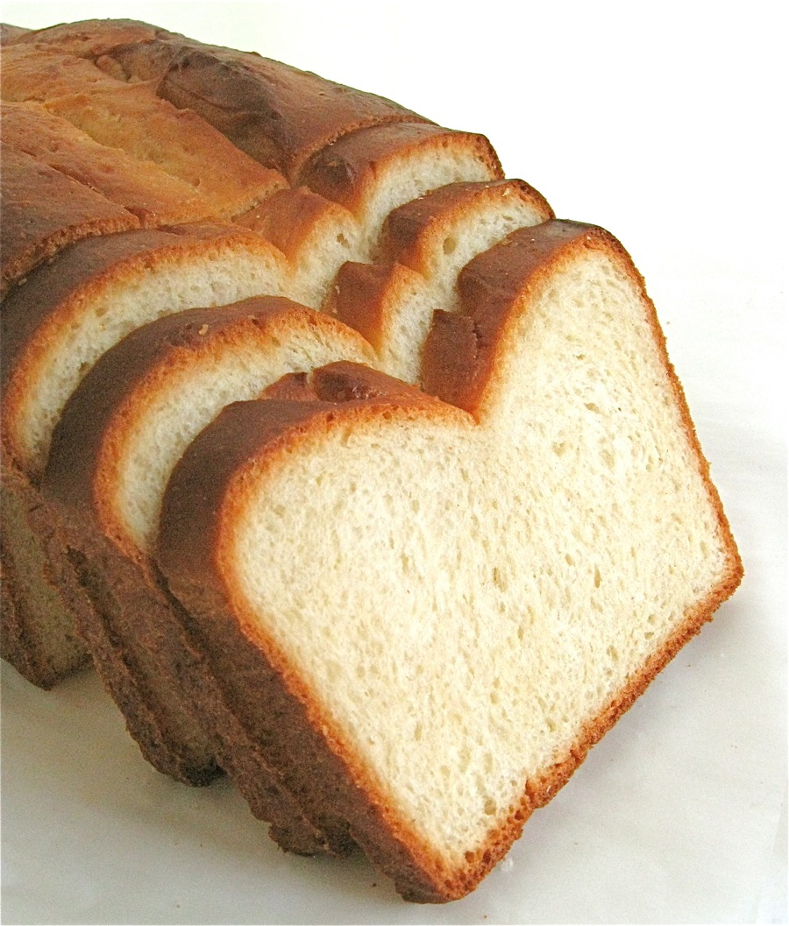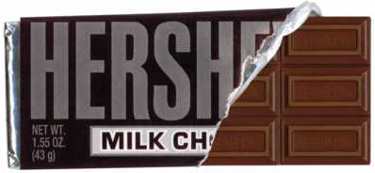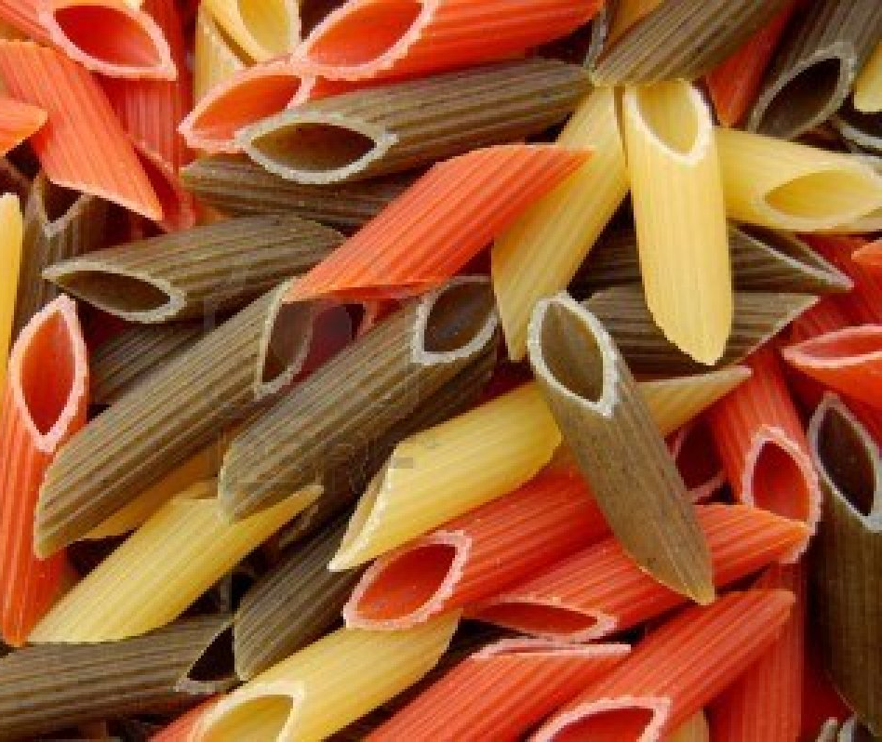
Lipids (Fats & Oils)
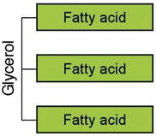
Contains CHO
Used for long term energy storage and insulation
Cell membranes (phospholipids) & steroid hormones
Made of a glycerol backbone and 3 fatty acid chains
Found in fried foods, meats, butter, etc.
Steroids are lipids that send messages throughout the body

Recognize them as a long letter E
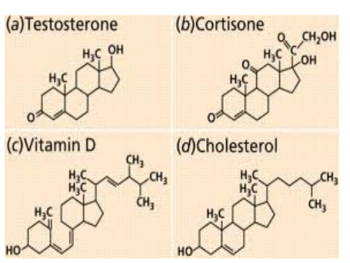
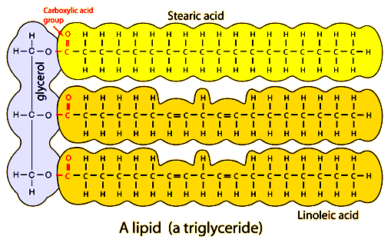
Everything really great tasting probably contains fat
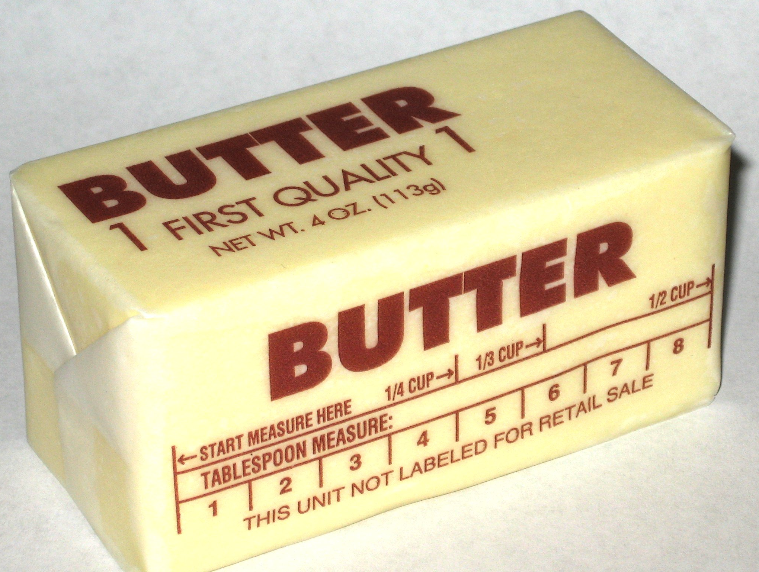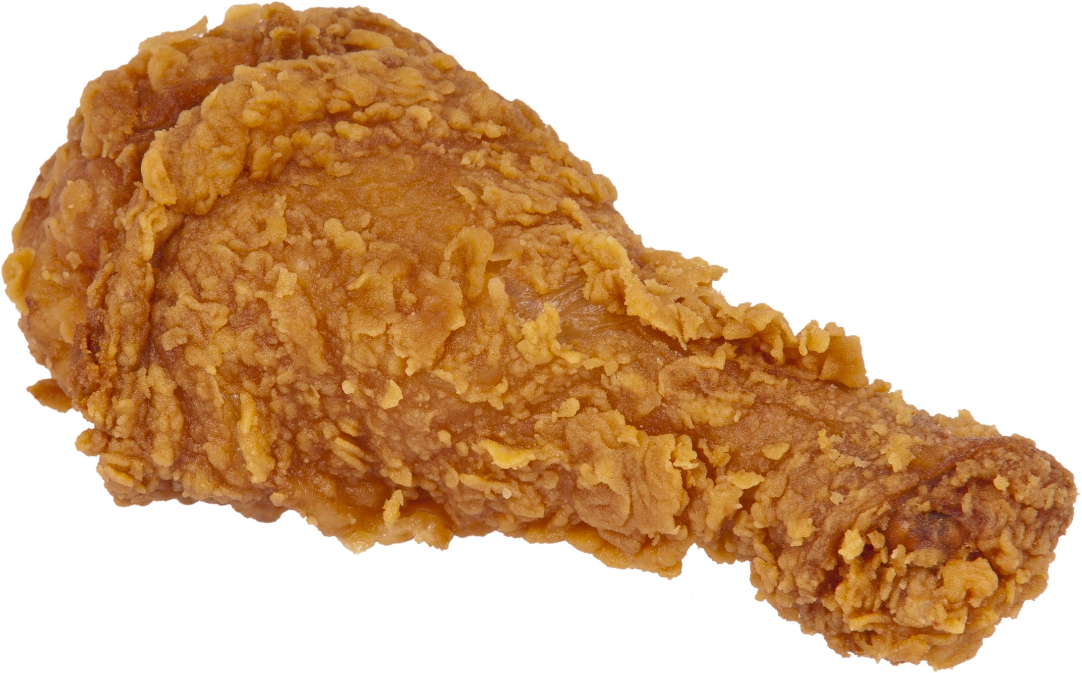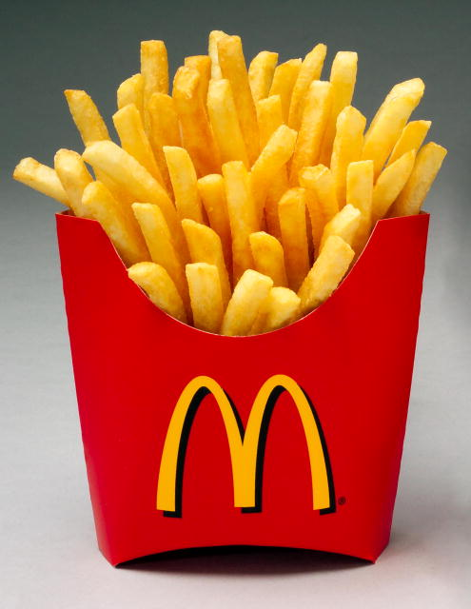

Proteins
Contains CHON
Used for building body structures Also used in things like insulin & hemoglobin
Insulin – a hormone that controls blood sugar levels
Hemoglobin – a protein that makes up red blood cells – transports oxygen through the blood
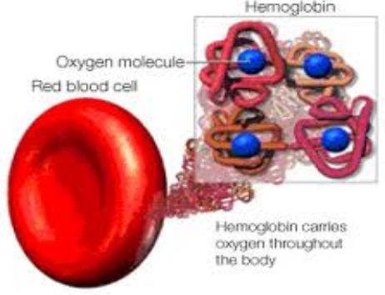
ProteiN

Also used for enzymes – to speed up chemical reactions
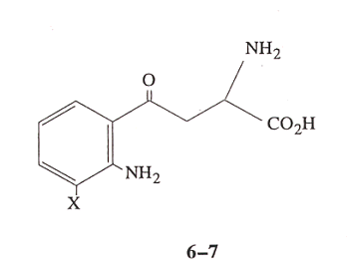
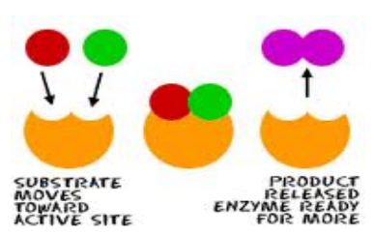

Made up of AMINO ACIDS
Found in meats, nuts, eggs, beans
You can recognize them because they contain NITROGEN
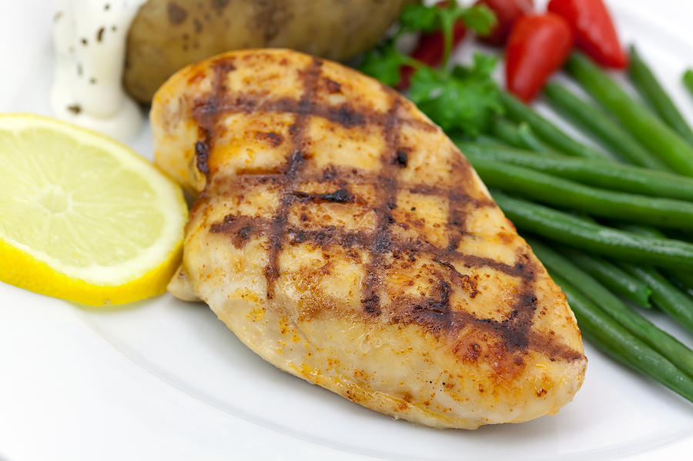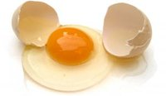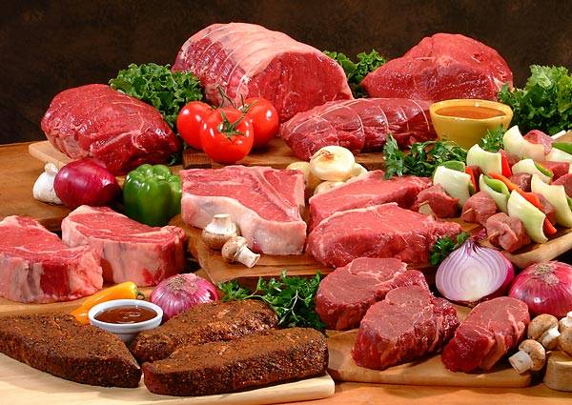

Nucleic Acids
Contains CHONP
Used to transmit and store hereditary information
Made up of NUCLEOTIDES
Each nucleotide is made of a sugar, a phosphate group & a nitrogen base
You find nucleotides in DNA and RNA
You can recognize them by having 3 distinct parts
DNA
RNA
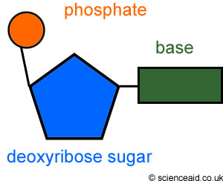
3 letters
Nucleotide – 3 parts

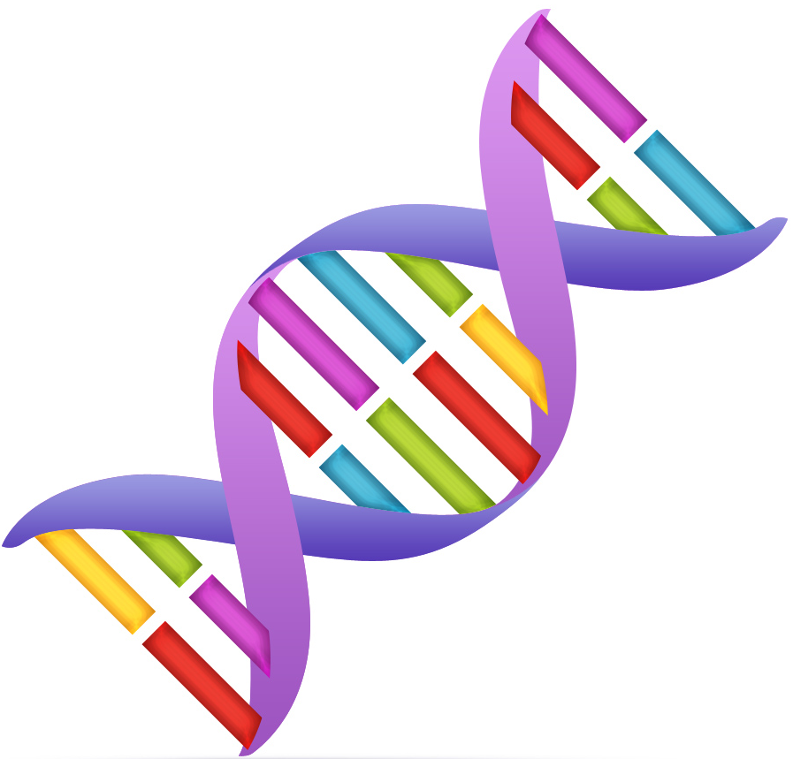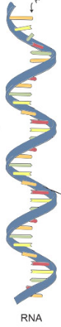
DNA

