Organic Compound Tests
Simple chemical tests with substances called _____________________ can be conducted to determine the presence of different organic compounds.
A ______________________________ of an indicator is usually a _____________________
______________________________________________________________________.
Carbohydrate (Glucose) Indicator Test – Benedict’s Solution
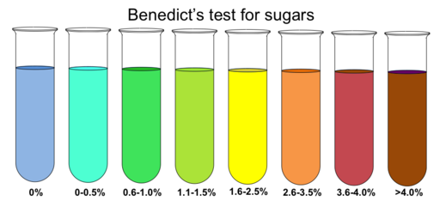
Add to samples and _________. If sugar is present the color will change from __________________________. The closer to red, the ___________________ the amount of sugar.

Starch Indicator Test – Iodine Solution
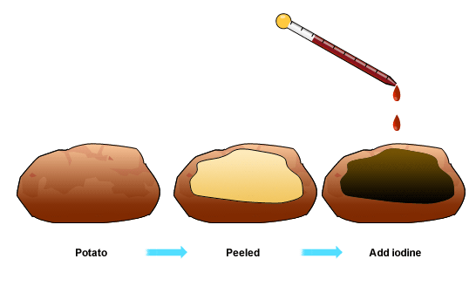

Add to samples. If starch is present the color will change from _______________________
____________________________________

Protein Test – Biuret’s Solution
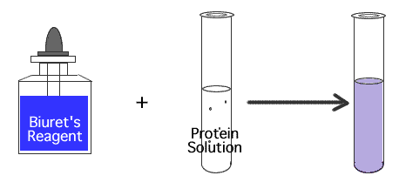

Add to samples. If protein is present the color will change from ____________________
________________________

Lipid Test – Brown Paper Bag

Add sample to brown paper bag. If lipid is present it will leave a ___________________
__________________ on the brown paper bag

