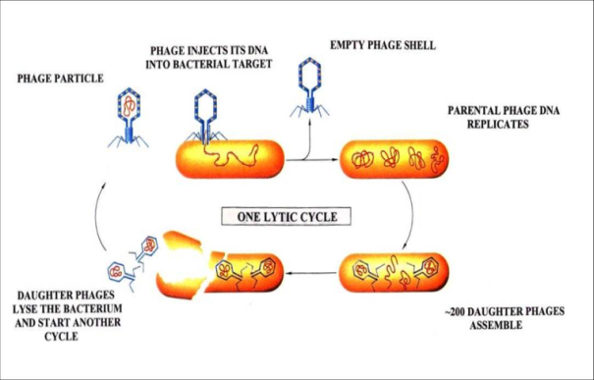
Viruses
The Six Kingdoms of Life Notes
- Do not belong to a ___________________
- Not living due to a lack of _______________ structure
- Can only reproduce in a _________ cell
- Composed of a capsid (_____________ coat) and nucleic acid (_______ or _________)
- ______________ - cause disease
- Examples: Chicken Pox, Influenza (flu), HIV, Ebola
- Reproduction: Lytic or Lysogenic Cycle

-Lytic Cycle: Virus invades the cell and takes over to produce hundreds of copies. The cell eventually bursts (lyses) and dies.
Lysogenic Cycle: Virus invades and hides in the DNA of a cell for a dormant period while it remains inactive. Under stress or another signal, the virus will begin the lytic cycle.
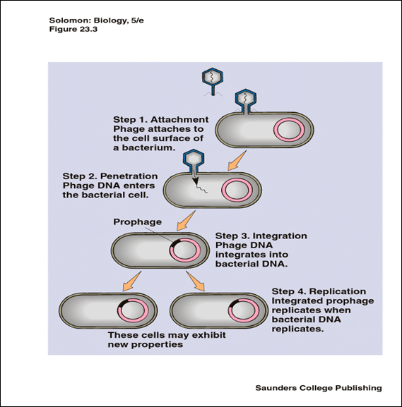
Archaebacteria
- Archae = ancient = oldest life forms
- _________________
- Cell Wall
- _______________
- Autotrophic and ____________________
- ______________ Reproduction (binary fission)
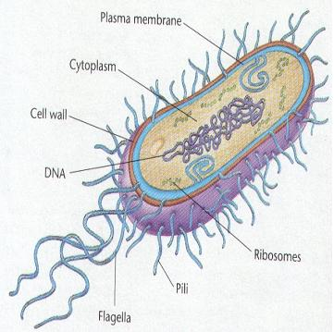
- Live in the harshest environments
- hot springs, deep _________ volcanic vents, ____________, sewage treatment plants
- Ex: Methanogens, halophiles (salt-lovers), Acidophiles (acid lovers), Thermophiles (________-lovers), Psychrophiles (cold-lovers)
- Very few species

Eubacteria
- _________________
- Cell Wall
- _______________
- Autotrophic and ____________________
- ______________ Reproduction (binary fission)
- Live in normal environments
- Ex: E. Coli, S. Aureus, Cyanobacteria (blue - green algae)
- _____________ species named
- 1 million estimated unnamed species

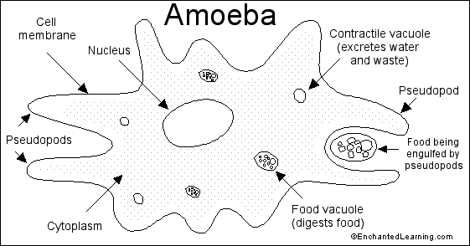
Protists
- Eukaryotic
- Three main groups:
- Algae (________________)
- Protozoa (___________________)
- Slime Molds (_____________________)
- Some protists are __________________ disease-causing
  - ______________ is caused by parasitic protists called plasmodia
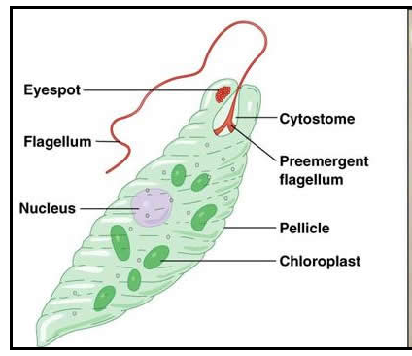
  - Mosquitos (_________________) carry/transmit plasmodia
  - Symptoms = headache, shaking, chills, fever
  - Some forms can lead to comas or death
- Algae:
  - Aquatic ____________________
  - Produce most of Earth’s ________________
  - Unicellular or multicellular (seaweed)
- Protozoa
  - Unicellular and aquatic
  - Animal-like
  - Adaptations to accomplish life functions:
- ___________________ = whip-like tail
- ____________ = tiny hair-like projections
- _________________ = extensions of the cell membrane
- _________________________ = for water balance; pumps water outside the cell
- ______________ = allows for responses to light
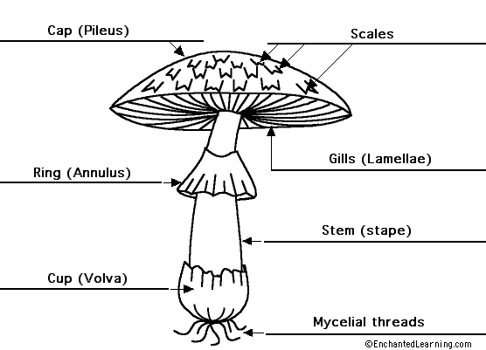
Fungi
- Eukaryotic
- Cell walls
- Mostly multicellular
- ________________ are unicellular
- Heterotrophic – obtain food through __________________ digestion (secrete enzymes and absorb nutrients across cell wall)
- Asexual Reproduction (____________ formation in mushrooms OR ______________ in yeasts)
- Sexual Reproduction (spores)
- Some are ________________
- Ex: fungi, molds, mushrooms, yeasts, mildews

Bacteria, Protists, Fungi
 | Bacteria | Protists | Fungi
Prokaryotes/Eukaryotes
Unicellular/Multicellular
Autotrophs/Heterotrophs
Cell Wall/No Cell Wall
Examples
Practice EOC Questions
1. Why are humans important to the life cycle of malaria parasites?
A. Malaria parasites kill humans.
B. Malaria parasites can live in mutual symbiosis with humans
C. Malaria parasites only live in human cells.
D. Malaria parasites use humans for reproductive purposes.

2. Which kingdoms have photosynthetic organisms?
A. fungi and plants B. fungi and protists C .protists and plants D. plants and animals
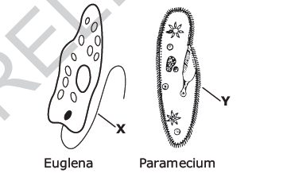
3. These diagrams represent a Euglena and a Paramecium. Which function do structures X and Y have in common?
A. digestion B. gathering food
C. movement D. reproduction

4. How does a eukaryotic organism differ from a prokaryotic organism?
A. The cells of a prokaryotic organism do not have membrane-bound organelles.
B. A prokaryotic organism does not contain DNA.
C. The cells of a prokaryotic organism are smaller than those of a eukaryotic organism
D. A prokaryotic organism has a nucleus; eukaryotes do not have a nucleus.
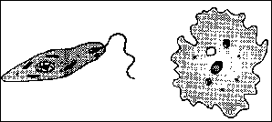
5. The diagrams represent unicellular organisms. In the past, they were difficult to classify as either plants or animals. Currently, these organisms are classified as:
A. coelenterates B. annelids C. tracheophytes D. protists

6. The life function of transport in an organism directly involves those activities used to:
A. absorb and distribute materials B. obtain and hydrolyze materials
C. release energy from food D. produce cellular waste products

7. Which term includes all the activities required to keep an organism alive?
A. growth B. excretion C. metabolism D. nutrition

8. According to the five-kingdom classification system, which two groups of organisms are classified as protists?
A. bryophytes and tracheophytes B. coelenterates and annelids
C. protozoa and algae D. bacteria and chordates
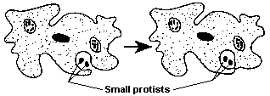
9. Which activity is illustrated in the diagram of an ameba?
A. egestion B. synthesis C. respiration D. ingestion

10. Every single-celled organism is able to survive because it carries out:
A. metabolic activities B. autotrophic nutrition
C. heterotrophic nutrition D. sexual reproduction

Plants
- Eukaryotic
- Cell walls with ________________
- Multicellular
- Autotrophic – Photosynthetic
- Mostly ___________ reproduction (pollen and eggs)
- Some ___________ reproduction (vegetative propagation)
- Can be non-vascular (no transport system) or vascular (transport system)
- Vascular have ___________ (carry water) and ______________ (carry nutrients) – most plants
- Non-vascular transport ________________ and nutrients from cell to cell by _____________ and diffusion – mosses
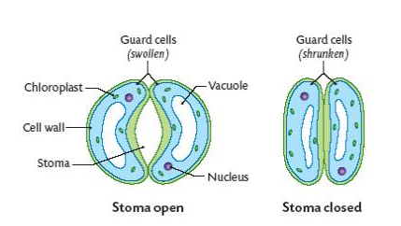
Non-Vascular Plants
- Lack __________________ tissue
- Ex: ferns, mosses, and liverworts
- Have sperm and egg on separate structures

Vascular Plants
- Xylem – transports water
- Phloem – transports nutrients (sugar)
- Special openings in surface = _______________
- Formed by two ___________ __________

Gymnosperms
- ____________ plant – have xylem and phloem
- Gymnosperm means “___________ seed”
- Their seeds are __________ protected by any outer covering
- Seeds are produced on the outside of ______________
- Gymnosperms include conifers (pine trees and spruce trees)
- Most pollination is caused by the __________
- Gymnosperms produce _________ in male cones which fertilizes _____ in female cones
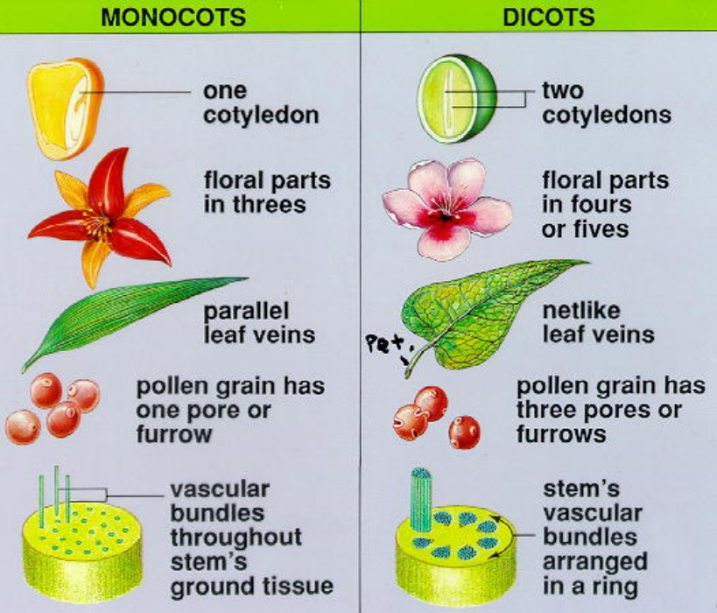
Angiosperms
- __________________ plant – have xylem and phloem
- Angiosperm means “____________ seed”
- Their seeds are protected by ovaries - which surround the seed and mature into ________
- Angiosperms also produce ______________ - which attract pollinators
- Pollination is caused by insects or birds that transfer ___________ from one flower to another
- Most plants are ________________________
- Angiosperms can be ________________ (one cotyledon) or ________________ (two cotyledons) – chart on page 570
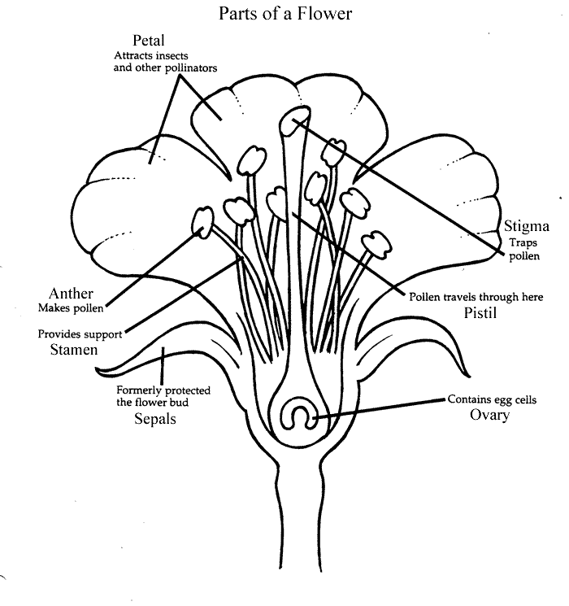
- Think of a girl named Angie – girls like flowers
- Reproduction:
  - ________ = male reproductive structure
    - anther (produces pollen containing sperm)
    - filament
  - __________/carpel = female reproductive structure
    - Stigma (sticky and collects pollen)
    - Style
    - Ovary (holds ovules containing eggs)
  - ___________________ = pollen is transferred to the stigma
  - ___________________ = pollen reaches and fuses with egg
  - The fertilized egg becomes a ____________
  - As the seed forms, the ovary swells and ripens to form __________ (aids in dispersal of seeds)

Tropisms
- Plant growth responses to external stimuli
- Examples:
- _________________ = response to light
- ____________________ = response to gravity (roots grow toward gravity; stems grow against it)
- ____________________ = response to contact (vine)

Plant Regulation
- Plants produce ______________ which regulate their growth and development and may control responses to stimuli
- Examples:
- ________________ = allow for elongation of the cell; allows the plant to bend
- ________________ = promote rapid cell division
- ________________ = promotes fruit ripening

Animals
Multicellular, ___________________, heterotrophs with NO cell ___________

- Invertebrates (_______ a backbone) – 95% of all animals
  - Ex: sponges, jellyfish, worms, insects, crustaceans, spiders, and starfish
- Vertebrates (have a ____________________)
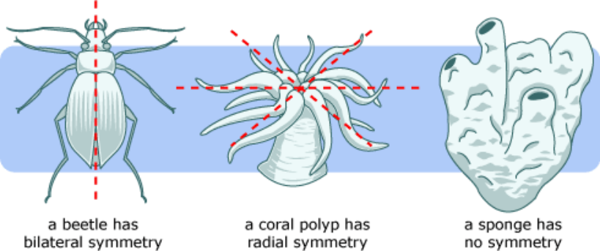
  - Ex: fish, amphibians, reptiles, birds, mammals
- Symmetry = whether one half of the animal matches the other half
  - ________________ - does not match (sponge)
  - ________________ - matches many ways (jellyfish)
  - ________________ - matches one way
- Segmentation – division of some animals into ___________________ parts (ex: earthworm)
- Cephalization – concentration of sense organs in a ____________ region

- STERNGRR:
  - _______________ - how organisms build necessary molecules
    - Protein synthesis – ribosomes are used to make proteins from amino acids based on DNA code
    - Lipid synthesis – the ER produces lipids like phospholipids for cell membranes
  - _______________ - how organisms get what they need to cells; move wastes
    - Blood cells carry nutrients and oxygen to cells and carry waste products away from those cells
  - _______________ - how organisms get rid of their waste and balance their fluids
    - Invertebrates → have specialized structures to filter waste from blood; _______________ in annelids and ____________________________ in insects
    - Vertebrates → use _____________ that are made up of nephrons to filter wastes
  - _______________ - how organisms get oxygen from the environment and release carbon dioxide back to the environment
    - Worms → oxygen can diffuse through moist ________ and enter bloodstream; large __________________________ to body volume helps increase diffusion
    - Aquatic invertebrates and vertebrates → use _________ to allow diffusion of oxygen from water into bloodstream
    - Terrestrial invertebrates → rely on _______ with alveoli (allow for fast diffusion of oxygen into blood and carbon dioxide out of blood)

  - _______________ - how organisms break down and absorb food
    - Insects have chewing mouthparts called _______________
    - Vertebrates have teeth
    - Digestive tracts include an esophagus, stomach, and intestines
    - _______________ - fingerlike projections that line the intestines and increase _____________________________
  - _______________ - sexual verses asexual types of fertilization
    - Sponges – fragmentation
    - Starfish - ____________________
    - Animals around water → _____________ fertilization (females lay eggs and males fertilize outside the body)
    - Land animals → _____________ fertilization
  - __________ and _________________ - metamorphosis, development in egg or in uterus
    - Insects and amphibians → undergo metamorphosis
      - ________________ metamorphosis = egg → nymph → adult
      - ________________ metamorphosis = egg → larva → pupa → adult
    - Reptiles, birds, and mammals → called monotremes lay _______________ egg (protective enviroment for the embryo to develop on land without drying out)
    - Marsupials → develop in mother’s pouch
    - Most mammals develop in uterus of the mother; _______________ connects the embryo/fetus to the mother’s circulatory system
  - _______________ - control the body’s responses by responding to stimuli and maintains homeostasis
    - ______________ - basic unit of the nervous system (found in animals)
    - ______________ - part of the endocrine system (found in plants and animals)

A Neuron
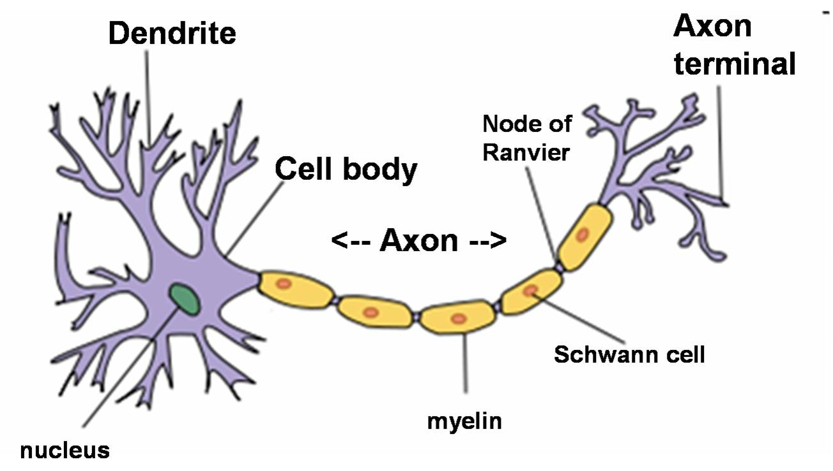

Practice Questions
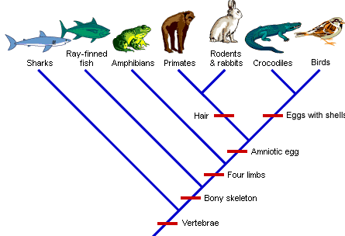

Characteristic | Sharks | Ray-Finned Fish | Amphibians | Primates | Rodents and Rabbits | Crocodiles | Birds
Vertebrae
Bony Skeleton
Four Limbs
Amniotic Egg
Hair
Eggs with Shells

1. The fertilized eggs of most mammals follow a similar pattern of early development. Which sequence is the typical pattern, beginning with the earliest stage?
A. fetus → embryo → zygote B. fetus → zygote → embryo C. zygote → fetus → embryo D. zygote → embryo → fetus

2. Which reproductive adaptation is more characteristic of mammals than amphibians?
A. external fertilization with internal development B. internal fertilization with internal development
C. external fertilization with external development D. internal fertilization with external development

3. Which group of mammals lay eggs? A. placentals B. monotremes C. marsupials D. umbilicals

4. Through which structure do developing embryos receive nourishment from their mothers?
A. placenta B. mammary glands C. egg D. diaphragm

5. What adaptation enables animals to reproduce successfully on land?
A. internal fertilization B. egg cells released from ovaries
C. fertilization outside the body of the female D. diploid gametes that undergo differentiation

6. Sandworms are annelid worms that live on the seafloor. They absorb oxygen and excrete wastes through their skin. Which characteristic will best help the worm carry out these functions?
A. large number of hearts B. large diameter blood vessels
C. large mouth compared to body volume D. large surface area compared to body volume

7. The structure of the digestive tube in the grasshopper and earthworm consists of many folds. The folds affect the efficiency of food absorption by which of the following functions?
A. increasing surface area B. reducing transpiration C. increasing hormone secretion D. reducing storage of sugars

