1. | This process is called
2.
3.
4. | This process is called
5.
6.
7.
8.
9.
10.

Fill in the spaces in the box below with the correct word choice above
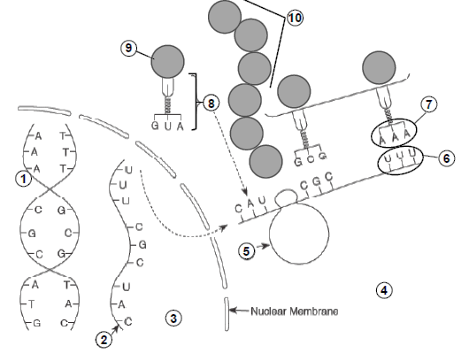
Name_______________________________________________
DNA nucleus anticodon translation protein codon
amino acid mRNA tRNA ribosome transcription cytoplasm

Fill in the spaces in the box below with the correct word choice above
Name_______________________________________________
DNA nucleus anticodon translation protein codon
amino acid mRNA tRNA ribosome transcription cytoplasm

1. | This process is called
2.
3.
4. | This process is called
5.
6.
7.
8.
9.
10.

